4ITRC2 Operating System Lab

Lab Assignment 5

**Aim**: To create C programs for the different scheduling algorithms.

**To perform**: Create and execute C programs for following CPU Scheduling Algorithms:

1. First Come First Serve (FCFS)

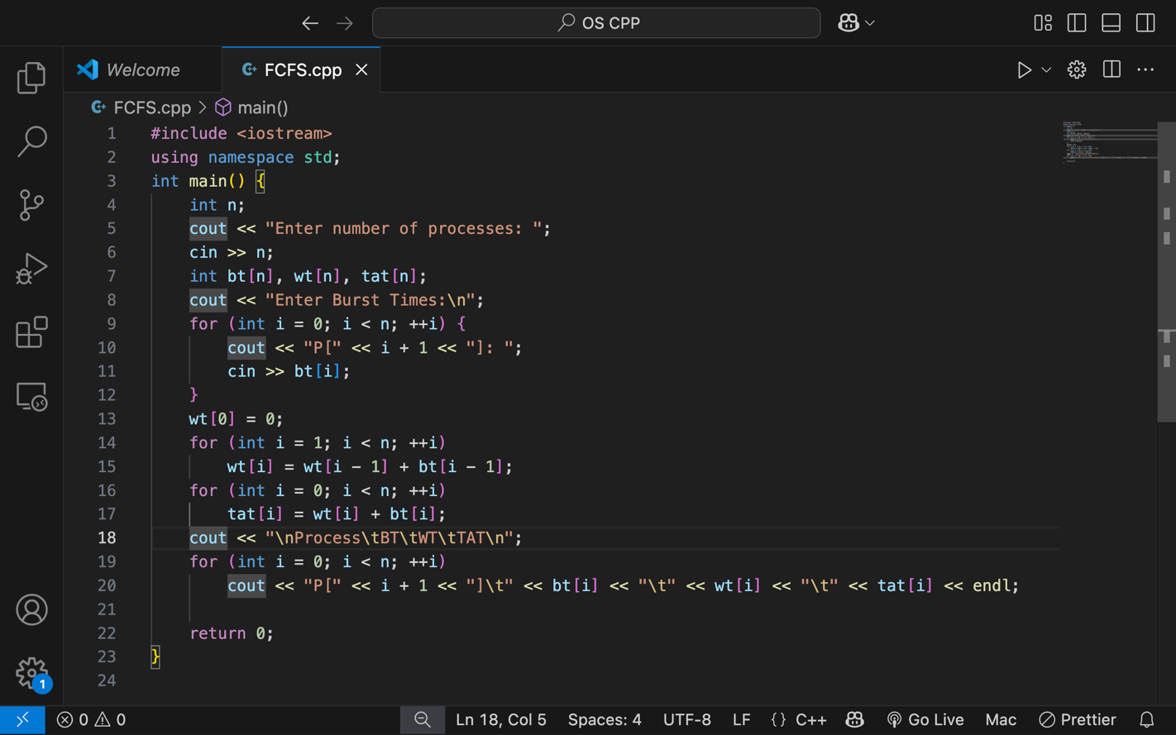

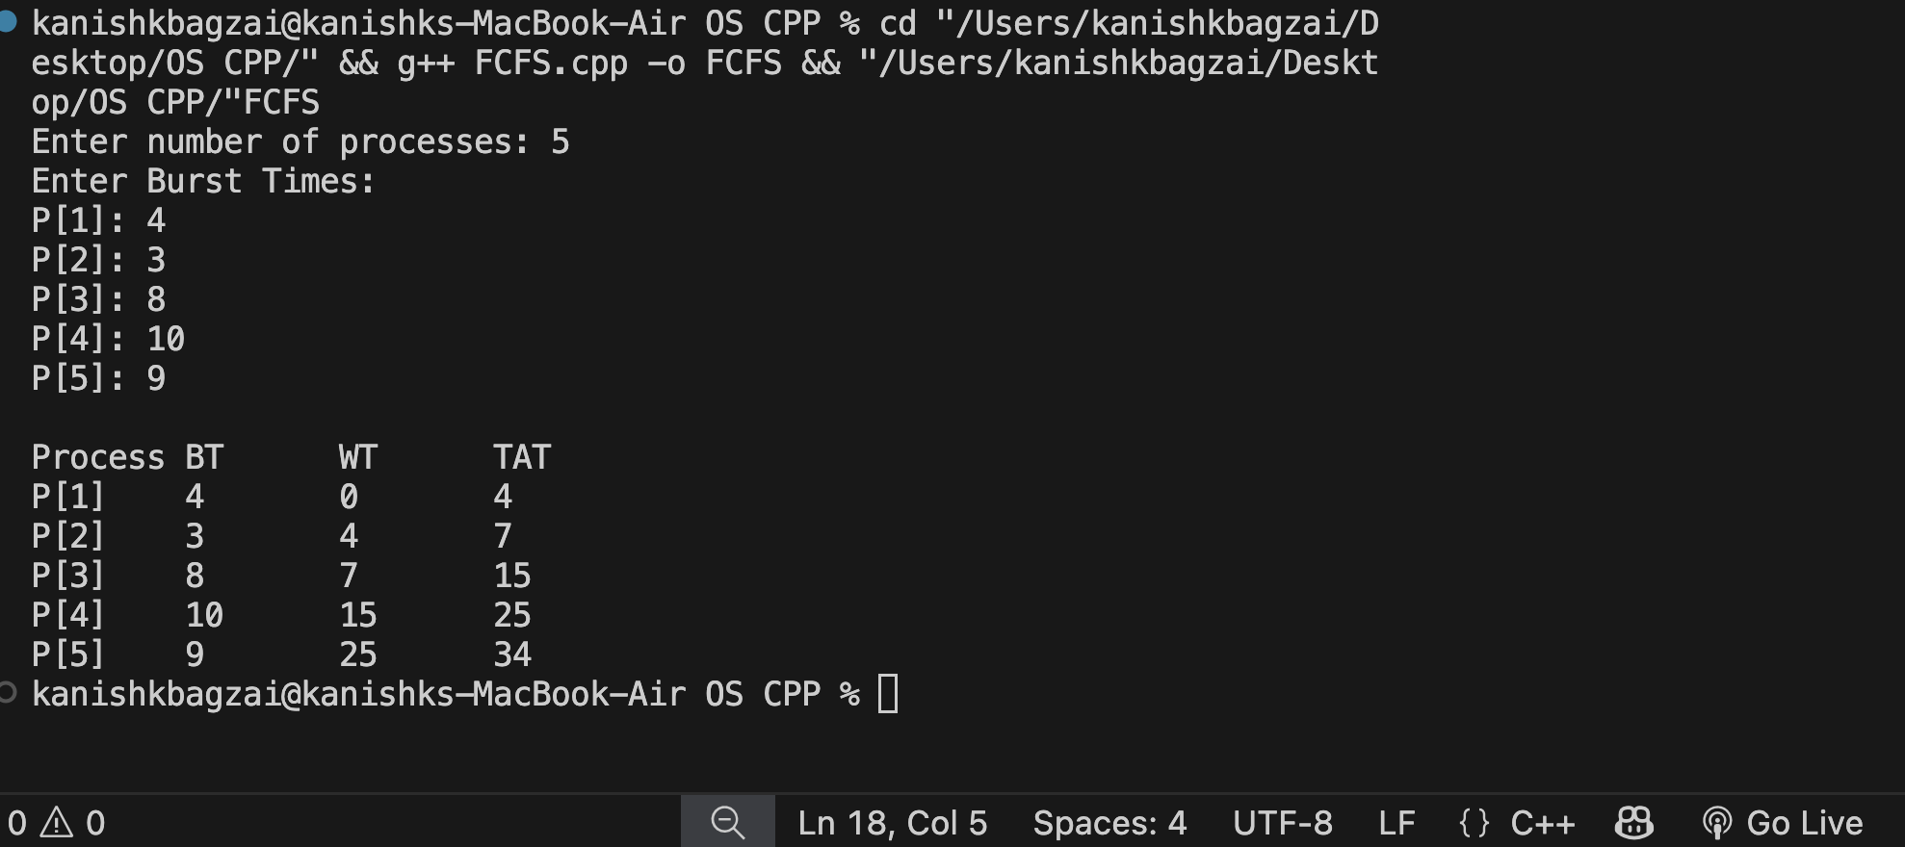

1. Shortest Job First (SJF)

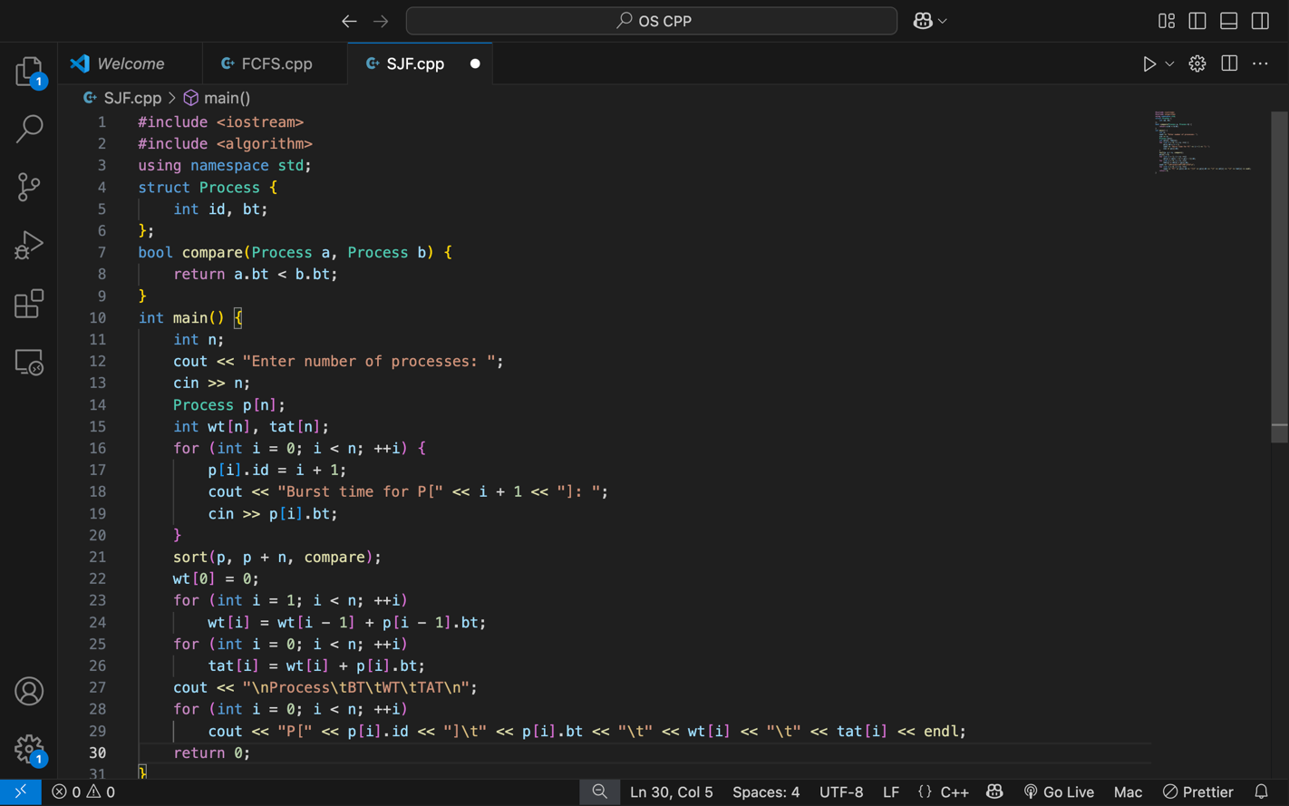

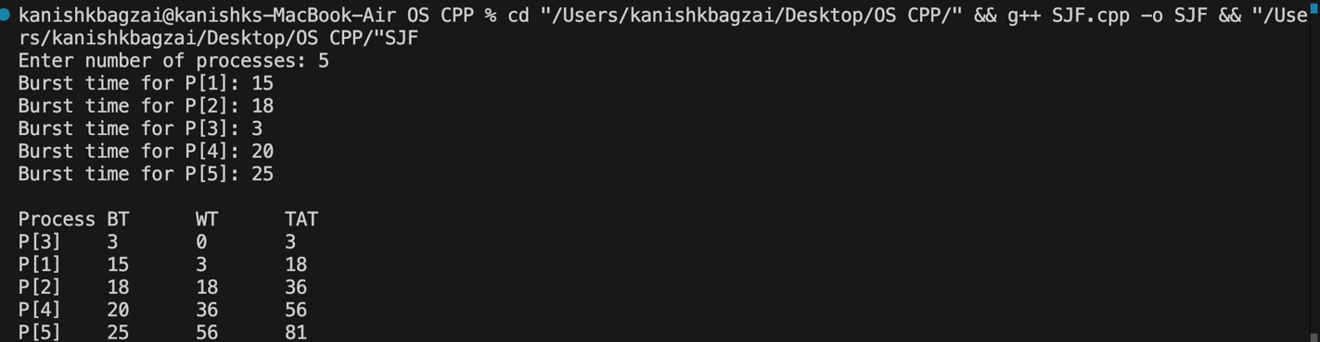

1. Round Robin Scheduling



